Killer denied parole after court ruling gets him an early hearing
By KATU.com Staff and Dan Tilkin KATU News Published: Nov 15, 2011 at 9:49 PM PST
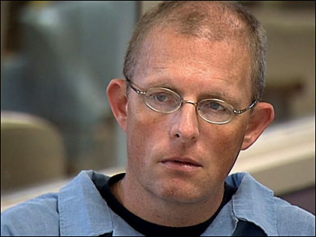»Play Video
Kevin Roper, who was sentenced to a minimum of 30 years for killing Eddie Gibbs in 1987, got a parole hearing early Tuesday because of an Oregon Supreme Court ruling. But Oregon's parole board denied him early release.

Related Content
- Murderer may get paroled early after Ore. Supreme Court ruling
SALEM, Ore. - A convicted killer, who came up for parole early because of an Oregon Supreme Court ruling, was denied release from prison Tuesday by the Oregon Parole Board.
Kevin Roper was the first prisoner among an initial wave of 30 killers from the 1980s and 90s to get parole hearings up to 10 years early because of that ruling.
Roper has been behind bars for 24 years for killing Eddie Gibbs, whose family pleaded with the parole board to keep Roper locked up at least for his original 30-year minimum sentence.
"This event makes you angry, hateful; it just takes years away from your life," Gibbs' brother Rod Toth told the board.
To convince the parole board he should be released, Roper had to describe how in 1987 he and another man lured Gibbs to the Powell Drive-in movie theater in Southeast Portland and beat him with a hatchet handle.
"The plan worked," Roper said. "I had the money. I had everything, and I keep asking myself that same question, why I didn't stop, why did I keep going forward? Why? I can still hear Eddie saying, 'Take the money. Take my money. I won't say anything.' He was begging. He was confused."
Roper and his accomplice lashed Gibbs to a speaker stand and strangled him with the cord. Then the killers used his money to get a bite to eat at a McDonald's.
While Roper was sentenced to 30 years to life, he could have been out this March if the parole board had let him.
But the board said he suffers from a "severe emotional disturbance that constitutes a danger to the health or safety of the community."
"We're happy," said Toth. "This is a victory for everybody, not just us. However, more people have more chances and you're just your playing odds, somebody may get through who's a danger to all of us."
Roper will get another hearing in two years. Over the next weeks and months the rest of the initial wave of 30 will have their parole hearings.
The board did have praise for how Roper has handled himself in prison and the education he's gotten. He's also part of a meditation group. But the board said it doesn't yet see him take real ownership of the deed he did.

